3D Geological model and reservoir simulation  
study of Concession nc74a

Fidda Reservoir

3d geological modeling   
Appendix 9.9 – isopach maps

Final Report



By

Heinemann Oil Gmbh

july 2016

List of Figures

Figure Appendix 9.6‑1: Isopach Map Facha A 1

Figure Appendix 9.6‑2: Isopach Map Anhydrate 1 2

Figure Appendix 9.6‑3: Isopach Map Facha B 3

Figure Appendix 9.6‑4: Isopach Map Facha B_sub1 4

Figure Appendix 9.6‑5: Isopach Map Facha B_sub2 5

Figure Appendix 9.6‑6: Isopach Map Anhydrate 2 6

Figure Appendix 9.6‑7: Isopach Map Facha C1 7

Figure Appendix 9.6‑8: Isopach Map Facha C2 8

Figure Appendix 9.6‑9: Isopach Map Facha C3 9

Figure Appendix 9.6‑10: Isopach Map Anhydrate 3 10

Figure Appendix 9.6‑11: Isopach Map Facha D1 11

Figure Appendix 9.6‑12: Isopach Map Facha D2 12

Figure Appendix 9.6‑13: Isopach Map Facha D3 13

Figure Appendix 9.6‑14: Isopach Map Facha E1 14

Figure Appendix 9.6‑15: Isopach Map MRZ 15

Figure Appendix 9.6‑16: Isopach Map Facha E2 16

Figure Appendix 9.6‑17: Isopach Map Facha E3 17

Figure Appendix 9.6‑18: Isopach Map Facha F1 18

Figure Appendix 9.6‑19: Isopach Map LRZ 19

Figure Appendix 9.6‑20: Isopach Map Facha F2 20

Figure Appendix 9.6‑21: Isopach Map LST 21

Figure Appendix 9.6‑22: Isopach Map Kheir 22

## Isopach Maps

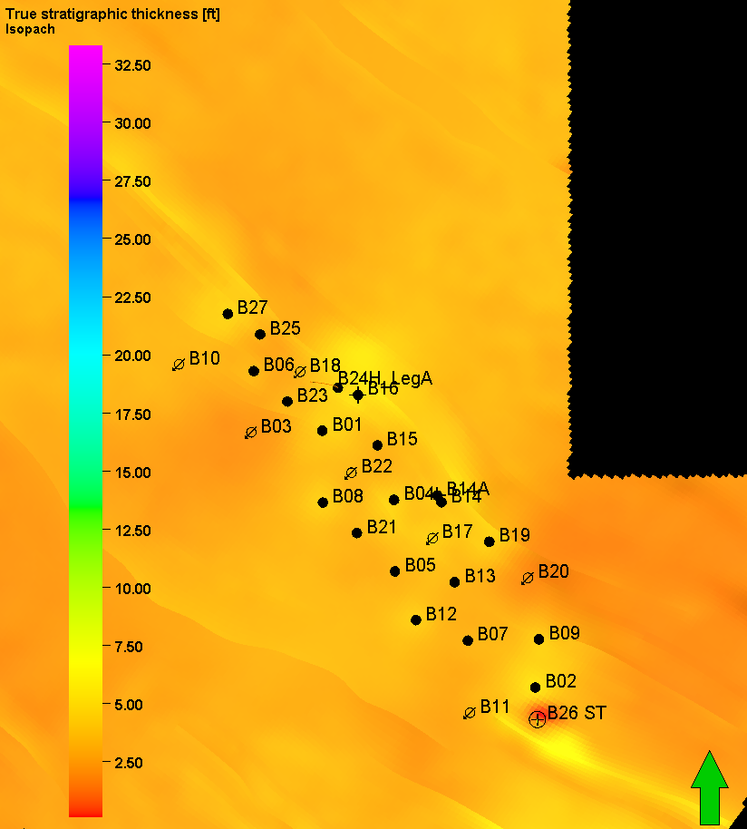

Figure Appendix 9.9‑1: Isopach Map Facha A

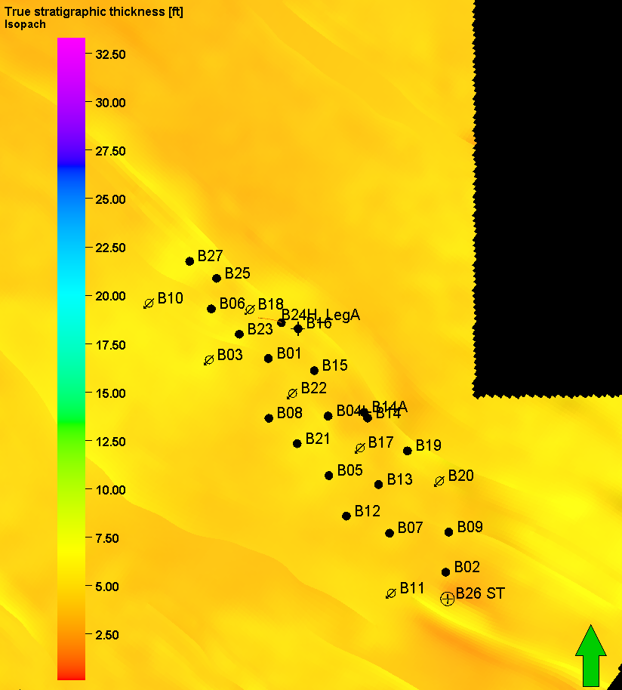

Figure Appendix 9.9‑2: Isopach Map Anhydrate 1

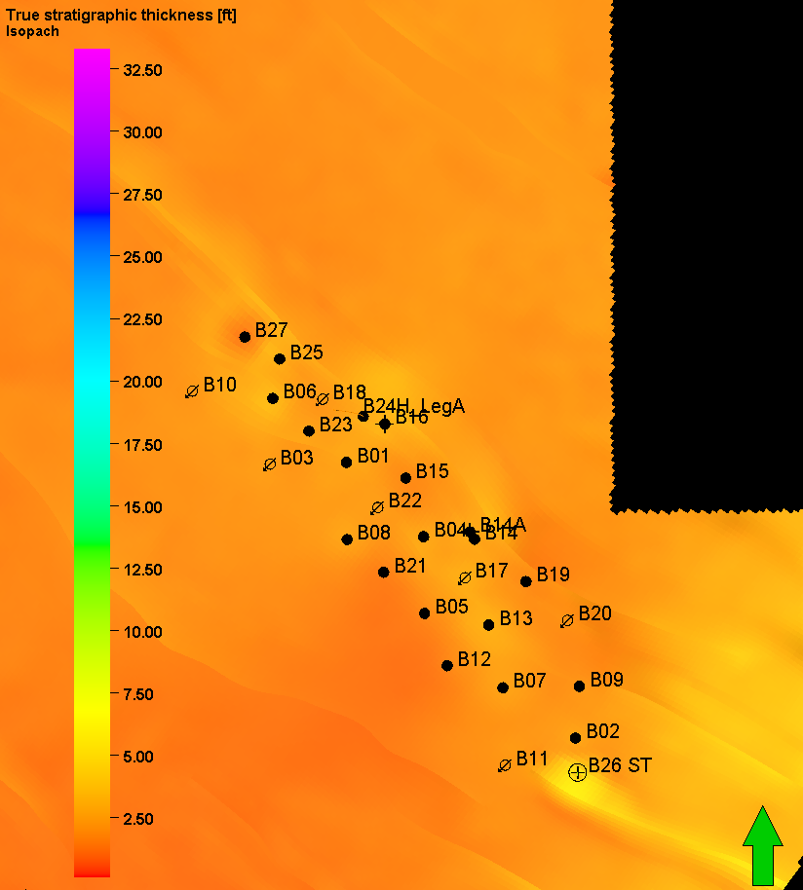

Figure Appendix 9.9‑3: Isopach Map Facha B

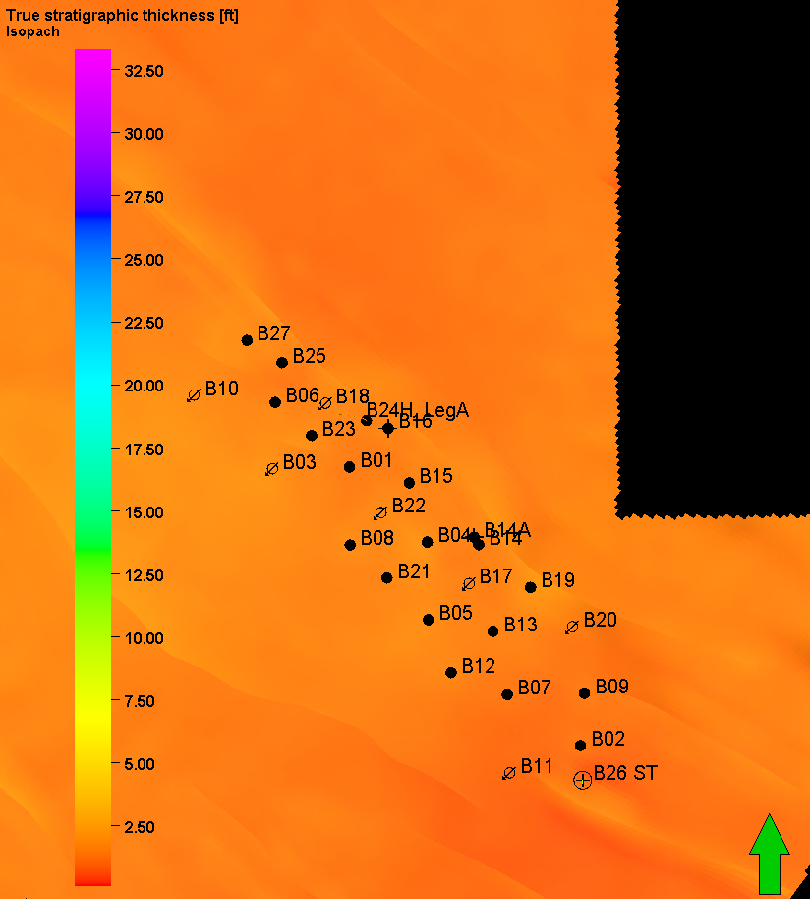

Figure Appendix 9.9‑4: Isopach Map Facha B_sub1

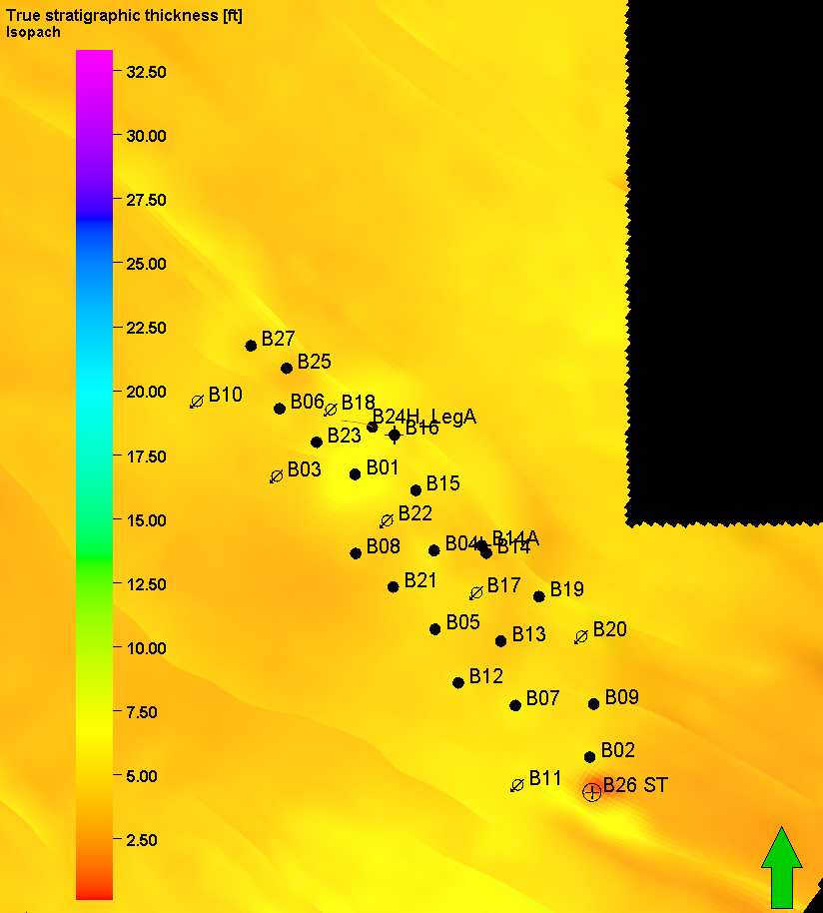

Figure Appendix 9.9‑5: Isopach Map Facha B_sub2

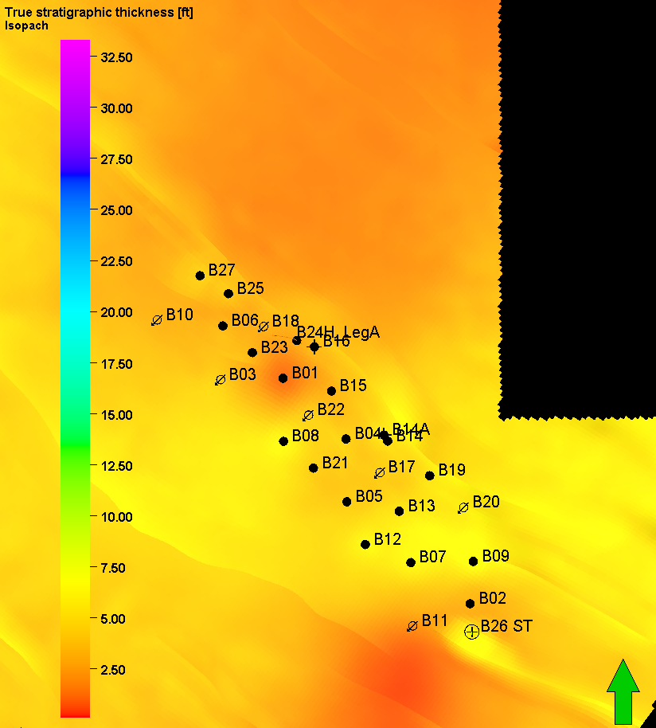

Figure Appendix 9.9‑6: Isopach Map Anhydrate 2

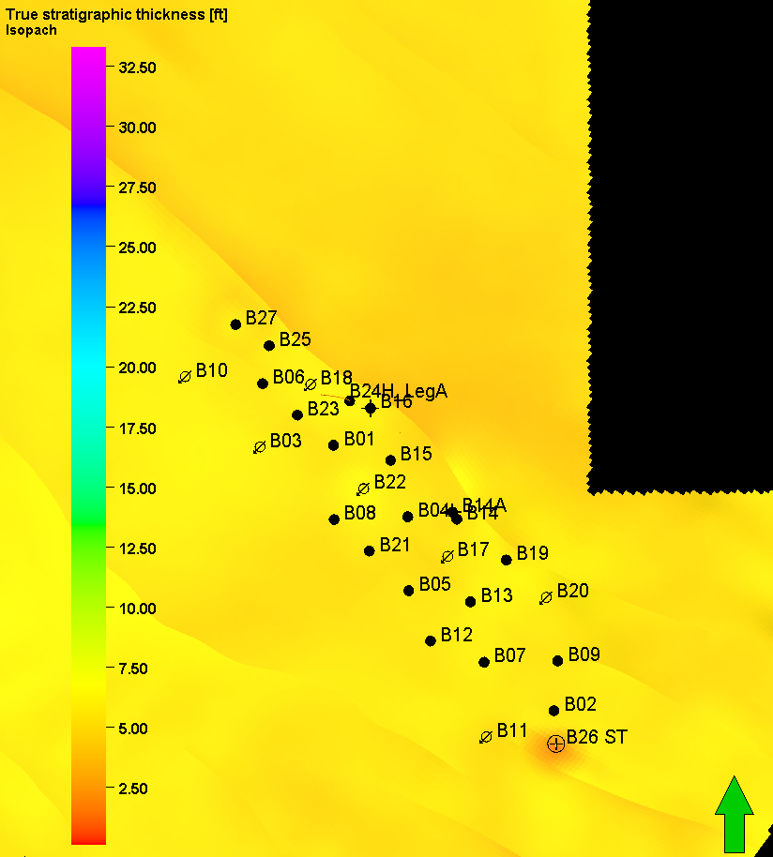

Figure Appendix 9.9‑7: Isopach Map Facha C1

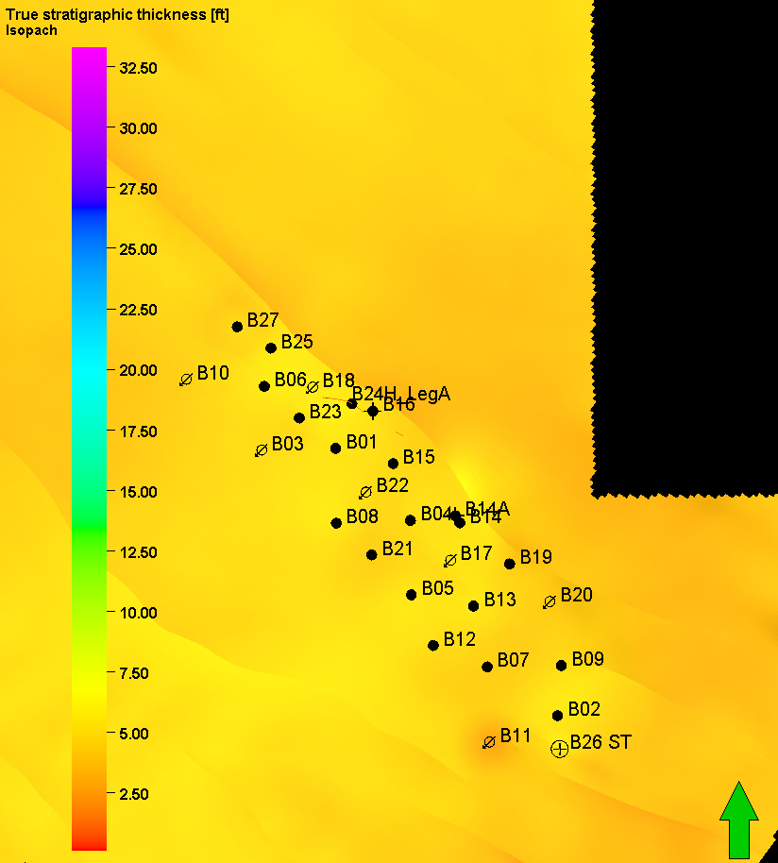

Figure Appendix 9.9‑8: Isopach Map Facha C2

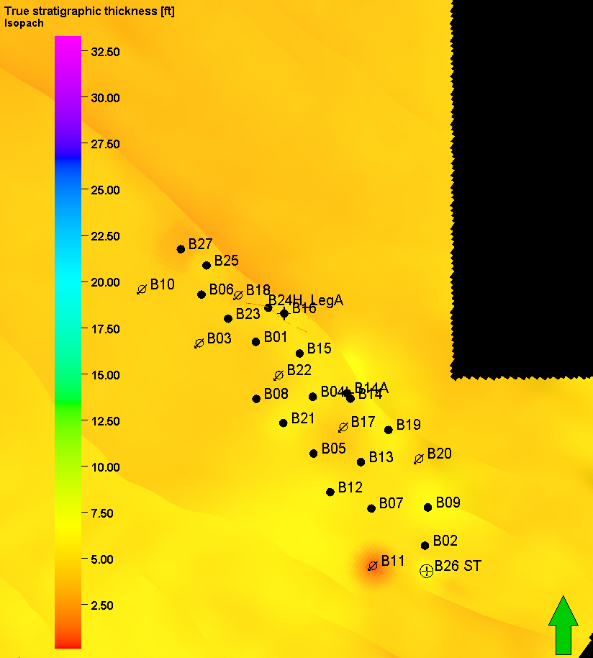

Figure Appendix 9.9‑9: Isopach Map Facha C3

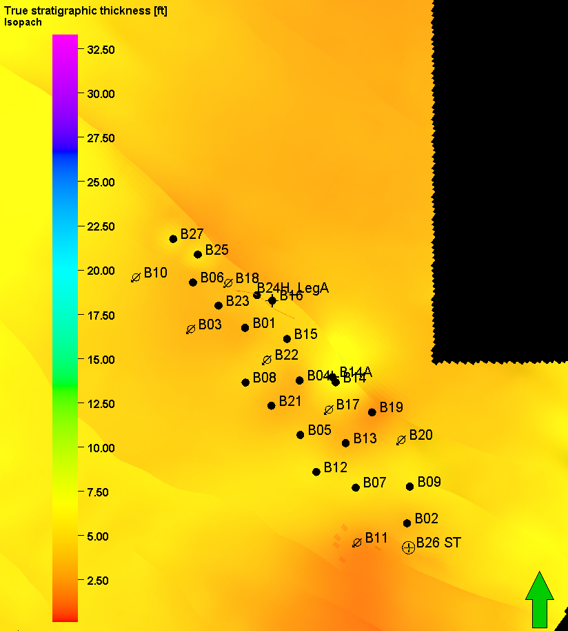

Figure Appendix 9.9‑10: Isopach Map Anhydrate 3

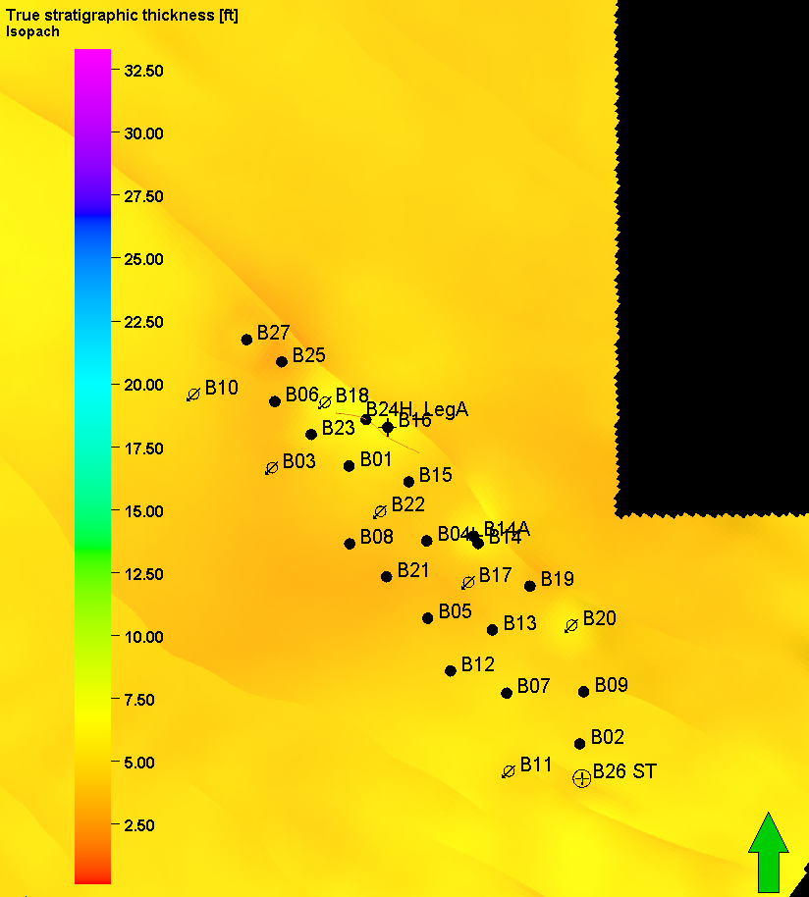

Figure Appendix 9.9‑11: Isopach Map Facha D1

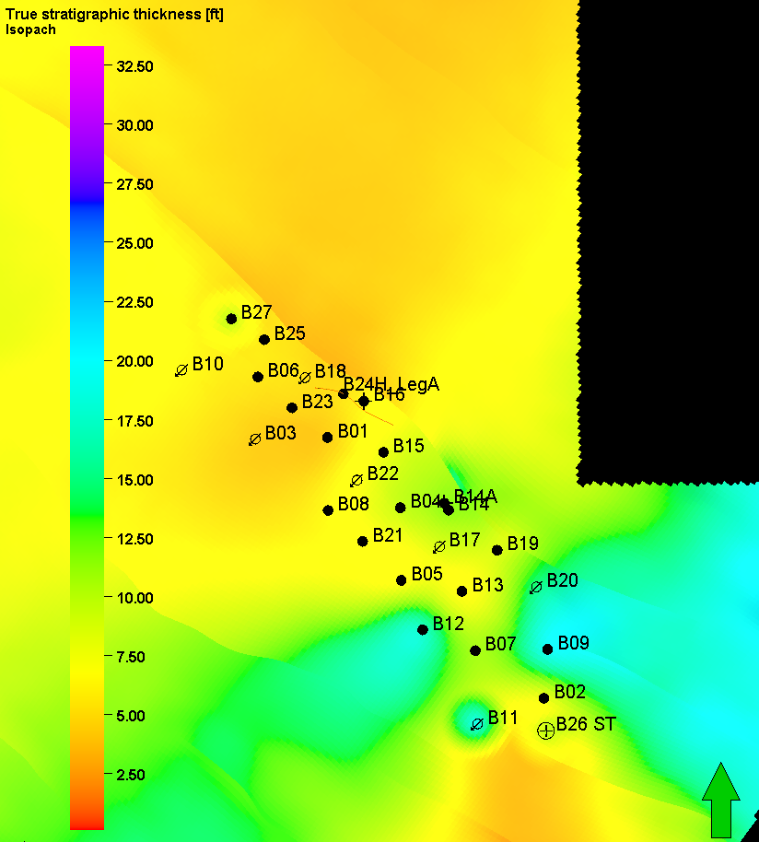

Figure Appendix 9.9‑12: Isopach Map Facha D2

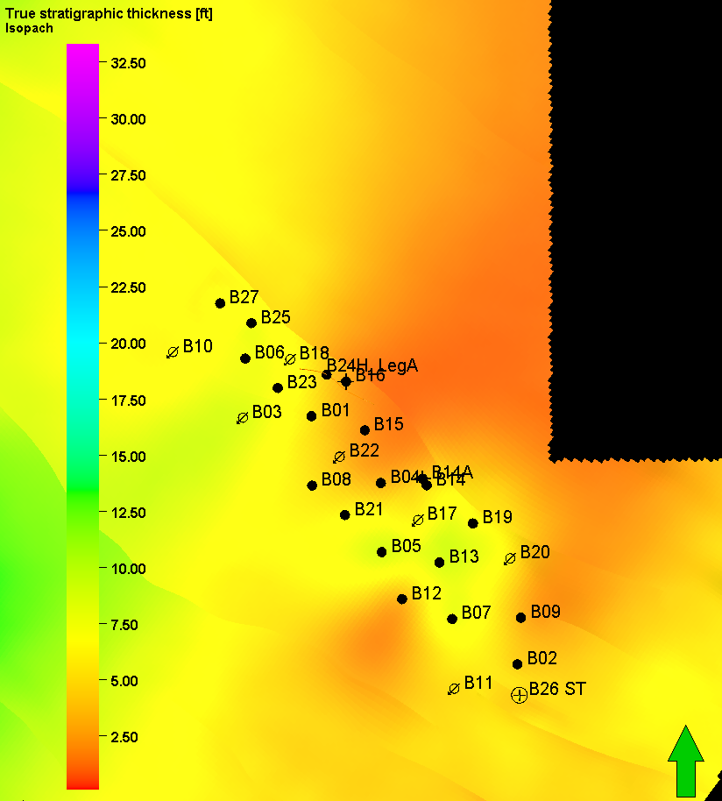

Figure Appendix 9.9‑13: Isopach Map Facha D3

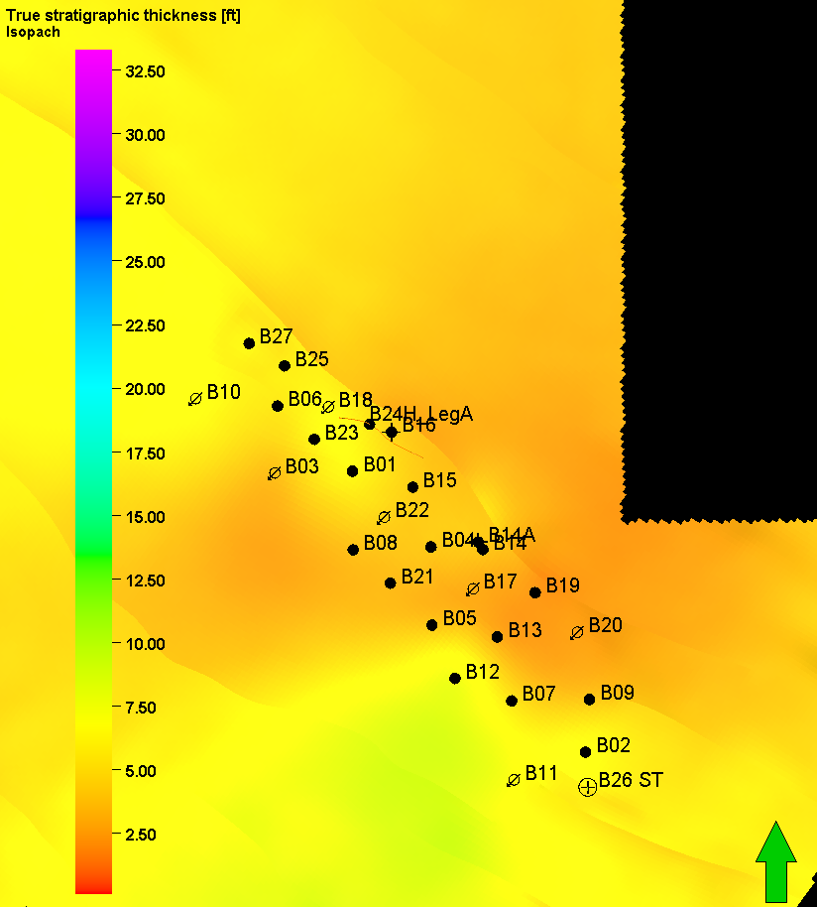

Figure Appendix 9.9‑14: Isopach Map Facha E1

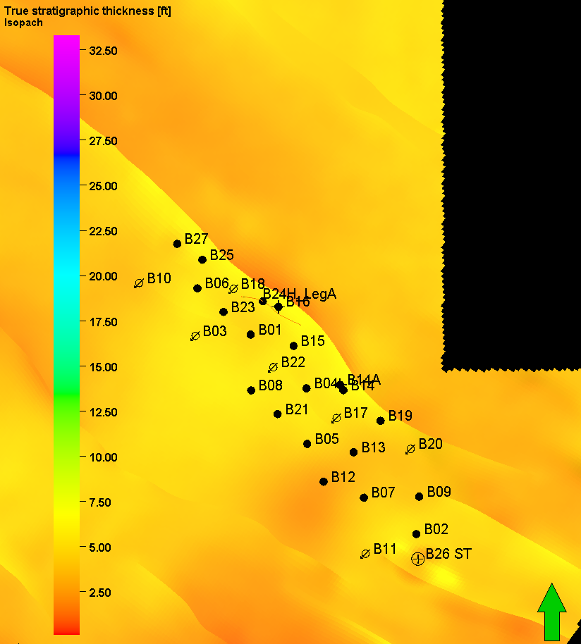

Figure Appendix 9.9‑15: Isopach Map MRZ

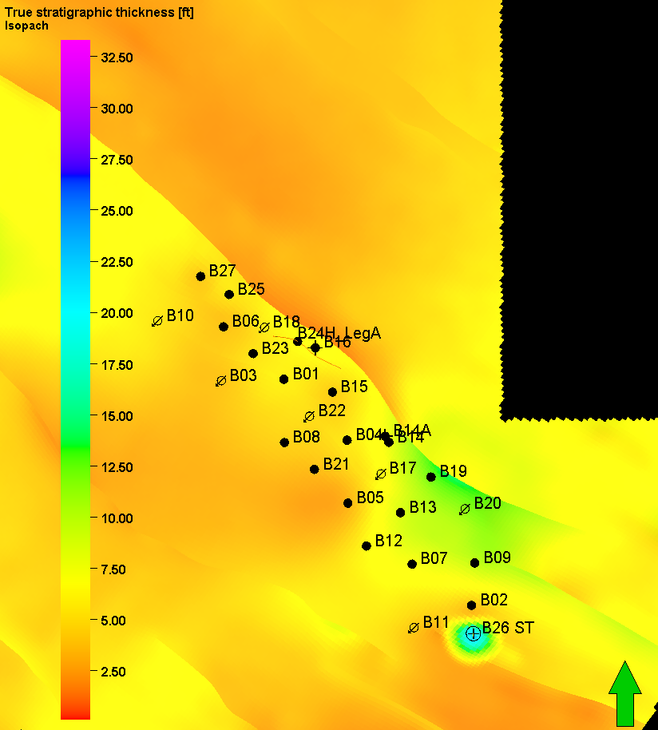

Figure Appendix 9.9‑16: Isopach Map Facha E2

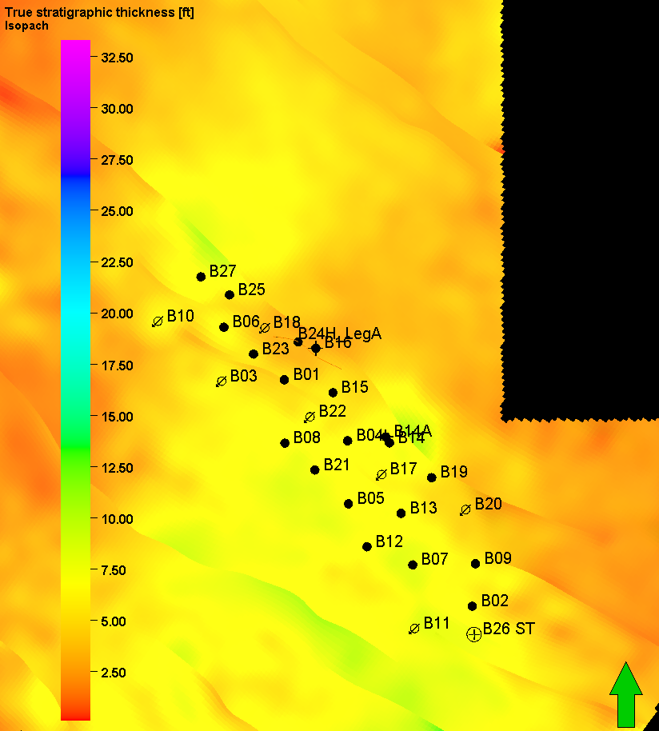

Figure Appendix 9.9‑17: Isopach Map Facha E3

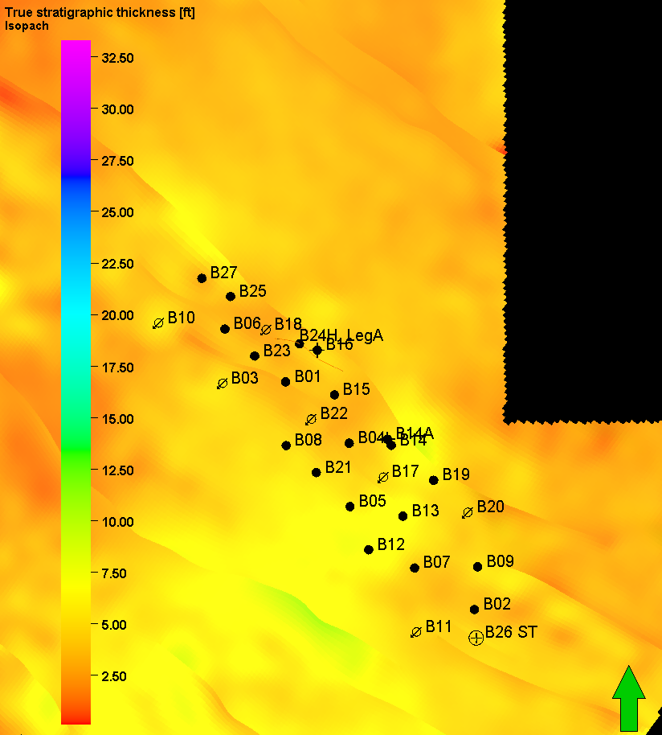

Figure Appendix 9.9‑18: Isopach Map Facha F1

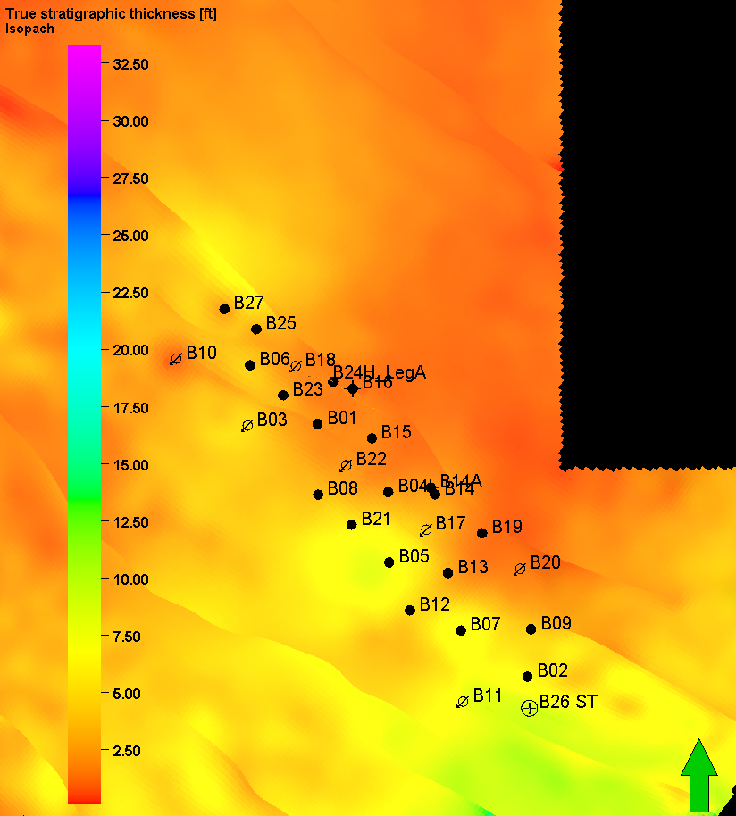

Figure Appendix 9.9‑19: Isopach Map LRZ

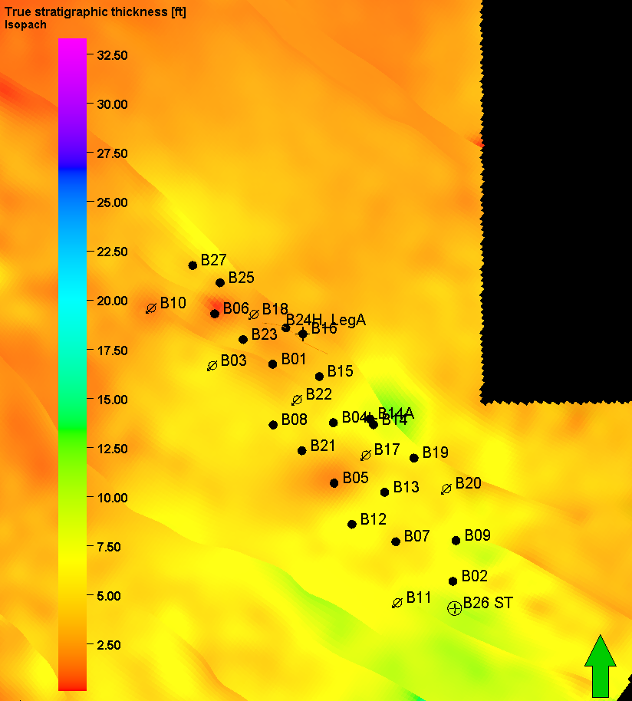

Figure Appendix 9.9‑20: Isopach Map Facha F2

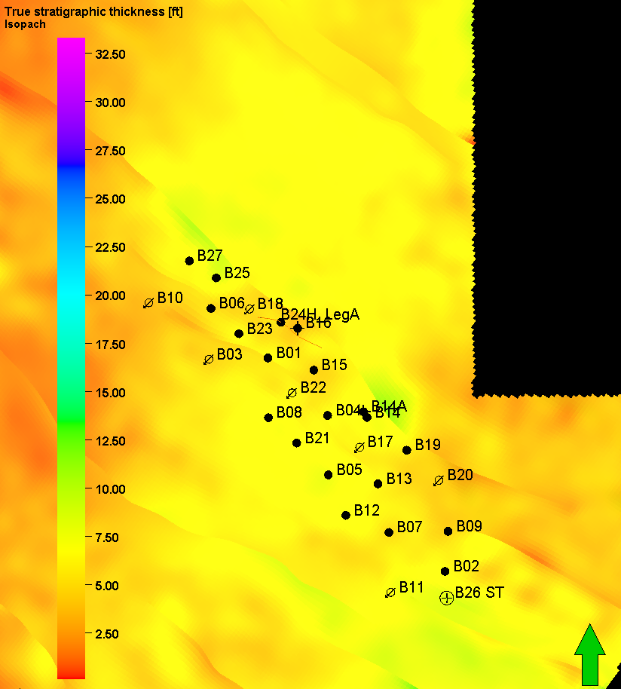

Figure Appendix 9.9‑21: Isopach Map LST

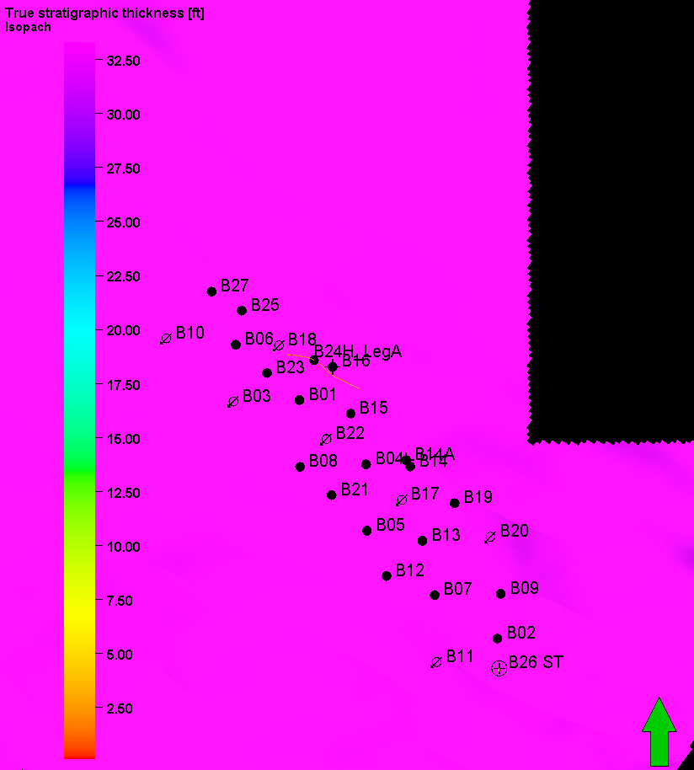

Figure Appendix 9.9‑22: Isopach Map Kheir